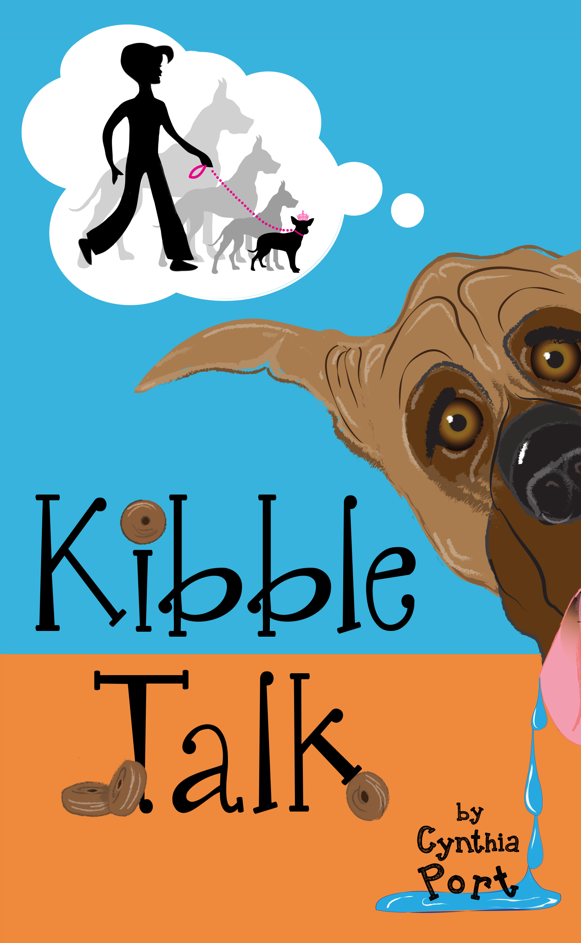 | KIBBLE TALK  Classroom Book Party!  By Cynthia Port

Please enjoy these book party activities and materials relating to my humorous middle grade novel Kibble Talk. I have tried to aim at the lowest common denominator age-wise (3rd grade), but offer some options for older students also. Please do not feel tied to these activities, and if you come up with some of your own that work well, I’d love to hear about them!

If you would like to include a classroom visit via Skype and/or correspond via email or letter please let me know. They can also visit my website (www.cynthiaportbooks.com) and FB page (cynthiaportbooks), or email me at Cynthia.l.port@gmail.com

Enclosed: 35 bookmarks (let me know if you need more)
35 blue ribbon dog show awards
35 Dinky coloring pages

- Simple Book Party Snack
During the book party, bring in breakfast cereal or crackers that look like dog kibble! (Captain Crunch, etc.) Let them put a handful in ziplock baggies, like Tawny did, so it will always be at the ready!

- Paying Attention to the People Around Us
Tawny discovered that the two most important people in her life (her mom and dad) weren’t completely happy, and that there were things she could do to help them be happier. Most of us have people in our lives that we sometimes forget to pay attention to. Often these are the people we see everyday, or nearly every day – a parent, brother, sister, neighbor, etc. Ask your students to write a note (or draw a picture) for this person, letting him/her know how much they love them and appreciate what they do, and asking if there is anything they can do to make that person even happier!

- Celebrating Who You Are
Tawny also learned from Dinky that being yourself, no matter how silly or strange it might seem to others, is important. Ask your students to draw pictures of themselves the way they’d really like to be – no matter what anyone else might think! When they are done, have a simple ceremony where they can share (if they want to) what they’ve drawn and why. After each share, give them a blue ribbon to wear!

Note: Instead of a drawing, students could play a charade/miming game, letting others figure out what they’d really like to be.

- What Would YOUR Pet Say?
Tawny was pretty surprised to hear her dog talking! He sounded funny with that squeaky voice! He also had some pretty interesting things to say about being a dog and getting to watch all the things that people do. If you could hear your pet talking, what would it sound like? What do you think it would tell you? Would it be funny, sleepy, high-energy, boring . . . Ask the students to draw one or more of their pets (doesn’t have to be a dog) and add a thought bubble. If a student does not have a pet, perhaps there is a classroom pet they could draw, or a neighbor’s or other family member’s pet.

Note: Older students can write a conversation between themselves and an animal or pet. This is a great exercise for getting yourself “into the head” of someone very different from you, which is something authors do every time they write.

- Get Moving
Let your students pretend that they are Dinky at the dog show! Bring in a scale and measuring tape – see if they can get their weight and height to be zero! Then get in groups of 3 -- Can they make a Dog Sandwich?

- Special Gift
Tawny discovers that she has a very special gift – talking to animals—but that having that gift is also a big responsibility. What are some other gifts that bring with them responsibilities? What does Tawny mean when she says she needs to use her gift wisely? What gifts do you have that you need to use wisely? If you were in Tawny’s shoes at the end of the book, would you have tried to turn Jenny into a kibble talker? Why or why not?

- Share Dinky With the World Wide Web!
Take a class picture of your book party and send it to me! With your permission, I will put it on my website and FB page. Students can also send me drawings of Dinky or the other characters and I will put them on my website!

Thank you so much! I hope you and your class enjoy Kibble Talk! I cherish all reviews from teachers, so please consider adding one to Amazon after you have read the book. Feel free to mention that you received a free copy and book party pack from the author.

If you decide not to use Kibble Talk for a class book party, please pass these materials and the book along to an elementary school teacher you think might be interested.

Sincerely,

Cynthia.l.port@gmail.com

